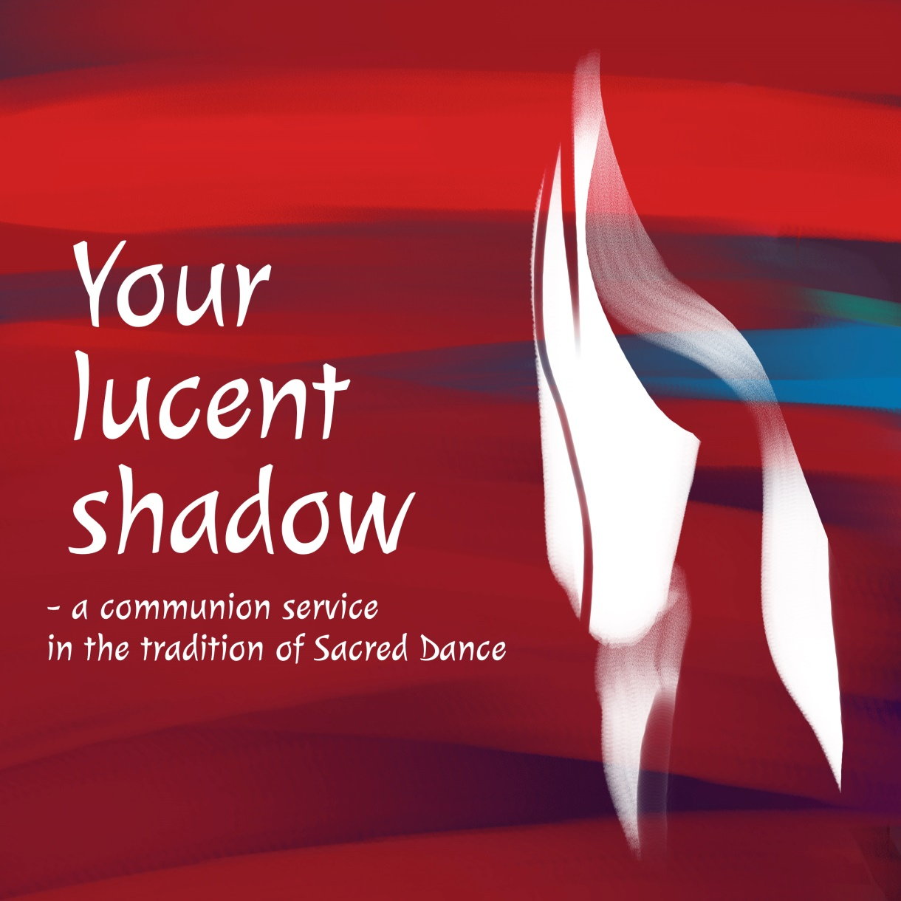

Music: Maria Hulthén Birkeland
Lyrics: Kristina Sandgren Furberg
Dances and movements: Hans Kvarnström

Your lucent shadow

– a communion service in the tradition of Sacred Dance

has come together through a close collaboration between author, composer and choreographer.
The order of service includes all the parts of a communion service. The imagery describes a movement from darkness to light and is inspired by the semi cycle of the day which takes us from dusk to dawn.

”Your lucent shadow” commences with a dance and song representing God living and dancing in our midst while time passes eternally.

It is followed by Introitus – Twilight time. The name of the service comes from this part.

“Precious one – Still your footprints can be seen. Your lucent shadow, like a dream your gaze embracing creation.”

The prayer for forgiveness comes during the midnight hour and dwells on our shortcomings and wrong doings. Kyrie, the prayer for God’s mercy is danced just before dawn. We ask for our empty cup to be filled, for God’s goodness to quench our thirst.

Through darkness and emptiness, we can finally perceive a faint light. Gloria, the time for praise is dawn. God comes to us as a much longed-for beam of light.

And then, at last, the sun rises above the horizon. Ever since the first Easter morning the sun is a strong and vibrant symbol of Christ. God promises to free us and we rejoice.

It is time for our communion. We sing and dance an interpretation of the Lord’s prayer. It expresses our yearning for completeness and grace – here and now and for eternity.

While we share the bread and wine we are in stillness. The choir sings a song of God rejuvenating us and giving us life. We receive the blessing and end the meal with a dance for every day. Paul writes in Rome 11: 36 “For from him and through him and for him are all things.”

The last part of the service is thanksgiving – on a mild summers morning we sing and dance, with all those who have gone before us and all the angels of heaven. We who have received the love of God long to give it on and on to others.

Opening – There is a dance

There is a dance keeping us in motion

it leads us through time and space.

There is a dance, movement to our heartbeat

it whirls us around.

Rising sun follows setting sun.

Waning, waxing moon.

Rising sun follows setting sun.

Waning, waxing moon.

Christ, you grant the dancing spirit.

Gift of vigor, gift of hope.

Help us liberate our senses

to receive uplifting joy.

There is a dance keeping us in motion

it leads us through time and space…

Christ, you filled our lungs our bodies,

inspiration, breath and life.

Help us in the fight for goodness,

holy fury, peaceful strife

There is a dance keeping us in motion

it leads us through time and space…

Christ, you dance as one among us,

through your movement show your means.

Give us courage facing darkness.

Go with us from death to peace.

There is a dance keeping us in motion

it leads us through time and space…

Introit – Twilight/The evening star appears

Twilight time-

All our daily toil is done.

With weighty burdens, we have come

to you who bear all our memories.

Setting sun –

Wait and watch while daylight flees.

Where force prevails and darkness breeds

the blessed daybreak seems distant

Precious one –

Still your footprints can be seen.

Your lucent shadow, like a dream

your gaze embracing creation.

Prayer for forgiveness – At midnight

Longing for deep harmony with each other,

We’re searching oneness with all.

We want to live unified with each other,

bound by our freedom to love

Oneness – where are you now

when darkness is all around?

Wholeness where are you now?

Brokenness keeps us apart -

at midnight.

Longing for deep harmony with each other,

We’re searching oneness with all.…

Kindness – where are you now

when distrust is all around?

Friendship where are you now?

Silence will keep us apart –

at midnight.

Longing for deep harmony with each other,

We’re searching oneness with all….

Waken us in our night

and lead us through dark and cold!

Watch and keep us tonight –

give us your hope that holds –

at midnight!

Kyrie – Howling of the wolves in the small hours

Kyrie eleison – let your mildness reach and heal me.

Christe eleison – illuminate my darkest hour.
Kyrie eleison – fill my cup with grace, let it run over.

Like a dry and infertile land, I am
Drought of the spirit, it plagues med.
This is all that I am – thirst.

As barren soil soaks up the rain
I would drink of you
but I am hardened – thirst.

Kyrie eleison – let your mildness reach and heal me…

Like a dim and desolate house, I am
Wolves are a-howling, they haunt me.
I am dark and locked up – now.

As rooms fill up with light and life
I would welcome you
but I am empty – now.

Kyrie eleison – let your mildness reach and heal me…

Like the grain that sleeps in the soil am I,
longing and listening stillness.
May I flourish with you now?

The grain that dies will live again.
Let me die with you,
let guilt and judgment go!

Kyrie eleison – let your mildness reach and heal me…

Gloria – Foreboding of light

Imminence of dawn.
O, trace of light
you speak to us of breaking day
and fill us with your hope.

Imminence of love.
Where you are near
togetherness and unity
abound, for you are All.

Imminence of faith,
Come soon, some now.
Be with us every step today
In every breath we take.

Sanctus – Christ, the resurrected Sun

Rosy skies and the sun is rising high,

Christ you’re alive and so are we.

Rosy skies and the sun is rising high,

Christ you’re alive and so are we.

We want to sing your praises

and have our home in hope.

We stand here with open hearts and loving you.

With freedom for imprisoned

and sight for blinded eyes

The end of our oppression

All through you.

Rosy skies and the sun is rising high,

Christ you’re alive and so are we…

You save us all from darkness.

The time of grace is here,

creation liberated all through you.

The times are ever changing

and one day time will end

eternal life is ours

all through you.

Rosy skies and the sun is rising high,

Christ you’re alive and so are we…

The Lord’s prayer – When your Kingdom comes

The hope of creation
is trust in your word,
your promise to be one
among us once more.
Come, bless and unify all people.

When your kingdom comes to
us, with gentle light
and raindrops that cool and soothe
the thirst of our lives,
we will rejoice with you among us.

When all fear has ended,
when our will is yours
when distance is lessened
and nearness is all,
your breath will sanctify our being.

When that day is dawning,
then freshly baked bread
and crystal-clear water
say shortage is dead.
Come let us dance and praise together.

When those we have harmed
will be healed once again.
our scars will bear witness
to love that retains
power of reconciliation!

Despair will find hope and
see light on that day
and truth will make peace
while all lies die away.
Glorious presence come to guide us.

The home we have sought
Will be here in plain view.
Your longing for us
Meets our longing for you.
Now and forever in your blessing.

Song during communion – You renew the Earth

We creatures depend upon you.

You open your hand and give us all goodness.

You send us your Spirit, new life is born,

renewing the Earth.

Ps 104: 27-30

A dance for each day

I am of you,
I am of you.
Your will shaped me as I am.
Through your blood I’m given life.

I am in you,
I am in you.
As your breath inspires me
it’s your thought that upholds me.

I go to you,
I go to you
and your stillness I await,
while I live for your embrace.

Prayer of thanks – Labyrinth of night

Labyrinth of night, you’ve brought us here

to this giddy summer’s morning, bees are humming.

Angels of the heavens - come dance with us!

Let the tambourine sound giving praise to our God.

Ever-filled with grace are you, our God.

Let us dance around you like a wreath of flowers.

Miriam and Mary, come dance with us!

Let the tambourine sound giving praise to our God.

Boundless is the love we have received.

Now we wish to share the gift of joy with others.

Peoples of all nations, come dance with us!

Let the tambourine sound giving praise to our God.

Translation from Swedish: Kristina S Furberg, Laura Jössing, Björn Sundmark.

Sacred dance

Sacred Dance is based on the conviction that movement to music is a basic human need and that it has a healing and spiritual dimension to it.

In the early days of the Church, Christians danced as a natural expression of their joy in Christ. It is even said that the early Church Fathers declared that as the angels in heaven danced, so should we humans dance on earth.

In our own time, Sacred Dance presents an opportunity for our body, with its senses to express itself spiritually. These dances have their roots in the folk dancing tradition and have been in use within the Church of Sweden since the early 1990s. Sacred Dance lends a certain dynamic to the liturgy. The dance steps and moves are so straightforward that no rehearsals are necessary. The dancing, just like praying or singing of hymns is done collectively during the service.

”Your lucent shadow” (Din ljusa skugga) was written in Swedish. It has been translated into German and English.

CD: www.naxosdirect.se
Sheet music: www.notpoolen.com
Dance instructions: www.youtube.com, ”Dansmässan Din ljusa skugga”

Facebook: Din ljusa skugga - en mässa i heliga dansertradition
Maria Hulthén Birkeland: www.mariahulthen.se and

Kristina S Furberg: www.kristinasfurberg.info

